Week 9 – Submit Task

Question 1

(VCAA Algorithmics Examination 2021)

You must also explain your answer below.

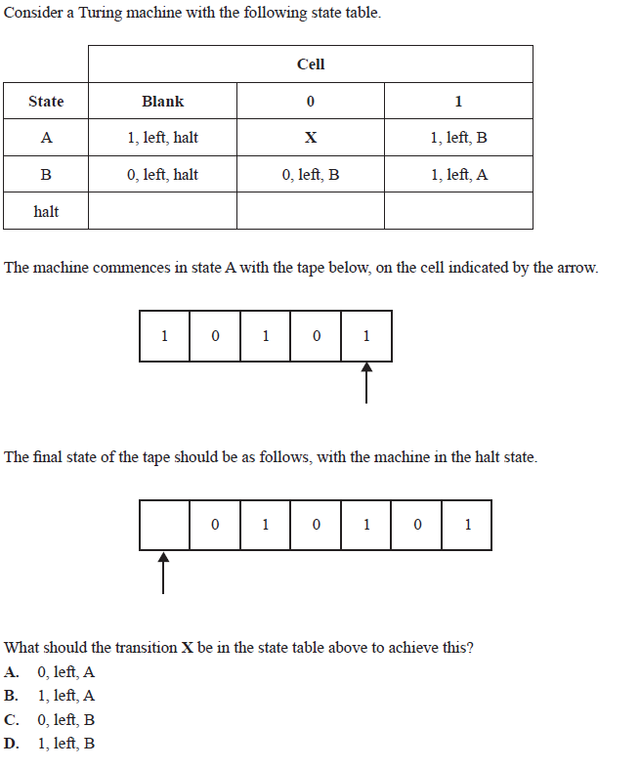

1. Reads 1, L -> B
2. Reads 0, L -> B
3. Reads 1, L -> A
4. Reads 0, We are now in X. This must write 0, so assume the answer is **A**, meaning now in state A
5. Reads 1, L -> B
6. Reads Blank, writes 0

This is correct, ∴ the answer is **A**

Each of the following questions is worth 2-3 marks. Provide a short written response.

Question 2

Explain the concept of a Turing machine and its components. How does it simulate the behaviour of a computer algorithm?

A Turing Machine is a hypothetical machine devised by Alan Turing. The machine consists of an infinitely long tape, which is analogous to the memory of a modern computer. It also has a head, and each “square” of the tape can contain one of a set number of symbols. Using the head, the machine can read the symbol on the square, edit the symbol on the square or move left or right by one square. Using these simple constraints, the Turing Machine can simulate any computable function, because it is a formalism for defining mathematics as the manipulation of a set of symbols.

Question 3

Define undecidability in the context of computer science. Provide an example of an undecidable problem and explain why it is impossible to solve algorithmically.

Undecidability is when an uncomputable problem requires a boolean response, namely when these problems cannot logically have an algorithm to solve them. An example of an undecidable problem would be the Barber Problem: on an island, there is only one barber, and he shaves all the men who do not shave themselves and only those men. Does he shave himself? Such a problem is undecidable because it leads to a logical contradiction in both cases. If he does shave himself, then he is not a part of the group that does not shave themselves, meaning he must not shave himself, but if that is the case then he must shave himself, and both cannot be true at the same time.

Question 4

Define the halting problem and explain why it is considered an undecidable problem. What are the consequences of its undecidability for the limits of computation?

The Halting Problem is the problem of determining whether any given algorithm with a certain input will continue running forever or eventually finish running (halting). If there does exist an algorithm that determines the above, we can define it as H(a,i) where a is the input algorithm and i is the input into a for which H determines if it halts or not. As such, it should be possible to define another function H+(a,i), which contains H and halts if H says the algorithm won’t halt, and does not halt if H says it will. The problem now asks what the output of H+(H, H+) will be and in either case the output will be wrong as H+ always does the opposite of what H says it will do. As such, it can be determined that no algorithm can be created that solves the Halting Problem, making it uncomputable. The consequences of this are that there exists no universal program that can predict the output of any other program, and that there exist problems that computers cannot solve in any case. It is also impossible to determine whether a program behaves as intended because its output cannot be predicted, meaning that perfect debugging programs do not exist.

Question 5

Discuss the relationship between the halting problem and Gödel's incompleteness theorems. How do they both relate to the concept of undecidability?

Gödel’s incompleteness theorem demonstrates how no system can prove its own consistency, meaning that we cannot use maths to prove that maths is consistent. Similarly, it proves that any consistent formal system which contains a certain amount of arithmetic contains statements which can neither be proved nor disproved using the said formal system. As such, both the Halting Problem and Gödel’s incompleteness theorem demonstrate the problem of undecidability and how there will always exist problems where the output cannot be determined.